**Adaplin Gel**

**MANUFACTURER**

[PSP Research Pvt Ltd](https://www.1mg.com/manufacturer/wallace-pharmaceuticals-pvt-ltd-55201)

**SALT COMPOSITION**

[Adapalene (0.1% w/w) + Clindamycin (1% w/w)](https://www.1mg.com/generics/adapalene-clindamycin-400050)

**STORAGE**

Store below 25°C

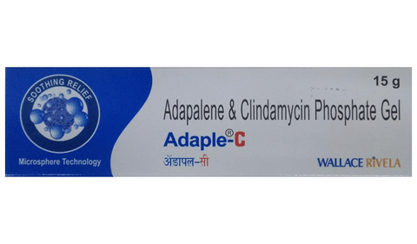

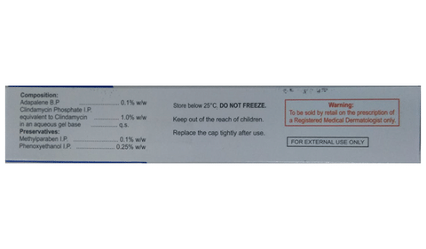

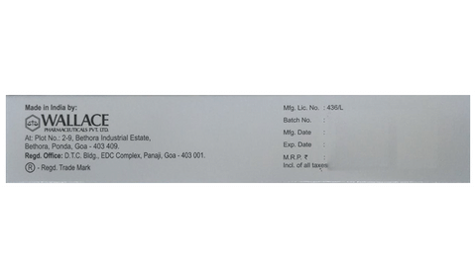

* 1
* 2
* 3

**PRODUCT INTRODUCTION**

Gel is a combination of two medicines that effectively treats acne. It minimizes oil production and helps to reduce inflammation. It also kills acne-causing microorganisms and prevents infection. This helps to prevent pimples, blackheads, and whiteheads on the skin.  
  
HydasoftGel is only meant for external use and should be used as advised by your doctor.  You should normally wash and dry the affected area before applying a thin layer of the medicine. It should not be applied to broken or damaged skin. Avoid any contact with your eyes, nose, or mouth. Rinse it off with water if you accidentally get it in these areas. It may take several weeks for your symptoms to improve, but you should keep using this medicine regularly. Do not stop using it as soon as your acne starts to get better. Ask your doctor when you should stop treatment.  
  
Side effects like minor itching, burning, or redness of the skin and oily skin may be seen in some people. These are usually temporary and resolve on their own. Consult your doctor if they bother you or do not go away.   
  
Inform your doctor if you have any problems with your bowels (intestines), or if you are using any other medicines to treat skin conditions. Consult your doctor about using this medicine if you are pregnant or breastfeeding.

**USES OF ADAPLIN-RGEL**

* [Treatment of Acne](https://www.1mg.com/diseases/acne-261)

**BENEFITS OF HYDASOFTGEL**

In Treatment of Acne

HydasoftGel is a combination medicine that helps treat acne (commonly called pimples) by reducing the production of sebum (a natural substance) that causes acne. This kills acne-causing bacteria and prevents spots or pimples from appearing. It usually takes a few weeks to have a noticeable effect so keep using it even if it appears not to be working. Sometimes acne may get worse before it gets better, however, with proper use, your skin will get clearer. The earlier you start using it, the less likely you are to get scars. This medicine will help improve your mood and uplift your confidence as your skin becomes acne-free. It should not be used if you have eczema or sunburned skin.

**SIDE EFFECTS OF HYDASOFTGEL**

Most side effects do not require any medical attention and disappear as your body adjusts to the medicine. Consult your doctor if they persist or if you’re worried about them

Common side effects of Adaple-C

* Skin peeling
* Erythema (skin redness)
* Itching
* Dry skin
* Burning sensation at the site of application

**HOW TO USE ADAPLIN-RGEL**

This medicine is for external use only. Use it in the dose and duration as advised by your doctor. Check the label for directions before use. Clean and dry the affected area and apply the gel. Wash your hands after applying, unless hands are the affected area.

**HOW ADAPLIN-RGEL WORKS**

Adaplin-RGel is a combination of two medicines: Adapalene and Clindamycin, which treats pimples (acne). Adapalene is a form of vitamin A which prevents accumulation of the sebum (skin’s natural oil), unblocks the pores and allows natural exfoliation of the outer layers of skin. Clindamycin is an antibiotic which works by penetrating into the skin and killing acne-causing bacteria.

**SAFETY ADVICE**

warnings

**Alcohol**

No interaction found/established

warnings

**Pregnancy**

CONSULT YOUR DOCTOR

Adaplin-RGel may be unsafe to use during pregnancy. Although there are limited studies in humans, animal studies have shown harmful effects on the developing baby. Your doctor will weigh the benefits and any potential risks before prescribing it to you. Please consult your doctor.

warnings

**Breast feeding**

SAFE IF PRESCRIBED

Adaplin-RGel is probably safe to use during breastfeeding. Limited human data suggests that the drug does not represent any significant risk to the baby.

warnings

**Driving**

No interaction found/established

warnings

**Kidney**

No interaction found/established

warnings

**Liver**

No interaction found/established

**WHAT IF YOU FORGET TO TAKE ADAPLIN-RGEL?**

If you miss a dose of Adaplin-RGel, apply it as soon as possible. However, if it is almost time for your next dose, skip the missed dose and go back to your regular schedule. Do not double the dose.

**All substitutes**

For informational purposes only. Consult a doctor before taking any medicines.

Adaplin-RGel

₹256/Gel

[Deriva-Cms Gel](https://www.1mg.com/drugs/deriva-cms-gel-156191" \t "_blank)

Glenmark Pharmaceuticals Ltd

₹349/gel

17% costlier

[Cleargel AP Gel](https://www.1mg.com/drugs/cleargel-ap-gel-374364" \t "_blank)

Hegde and Hegde Pharmaceutical LLP

₹325/gel

9% costlier

[Nioclean AD Gel](https://www.1mg.com/drugs/nioclean-ad-gel-155001" \t "_blank)

KLM Laboratories Pvt Ltd

₹185/gel

38% cheaper

[Faceclin AT Gel](https://www.1mg.com/drugs/faceclin-at-gel-768344" \t "_blank)

Abbott

₹318/gel

7% costlier

[Adalene Nanogel Gel](https://www.1mg.com/drugs/adalene-nanogel-gel-134348" \t "_blank)

Zydus Cadila