**ET-EziGel**

Prescription Required

**MANUFACTURER**

[PSP](https://www.1mg.com/manufacturer/zydus-cadila-73859) Research Pvt I ltd

**SALT COMPOSITION**

[Etoricoxib (10mg) + Linseed Oil (30mg) + Menthol (50mg) + Methyl Salicylate (100mg)](https://www.1mg.com/generics/etoricoxib-linseed-oil-menthol-methyl-salicylate-405643)

**STORAGE**

Store below 30°C

Click here to view all substitutes

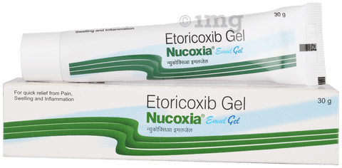

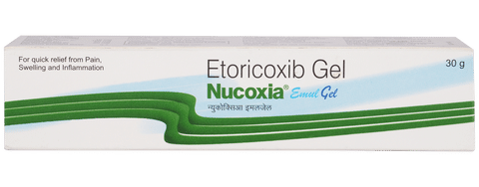

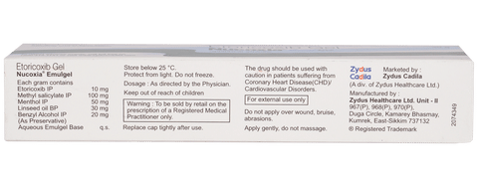

* 1
* 2
* 3
* 4
* 5
* 6

**PRODUCT INTRODUCTION**

Loco-Ezi Gel is a pain relieving medicine applied topically to relieve pain. It is used to treat pain and inflammation in conditions like rheumatoid arthritis, ankylosing spondylitis, and osteoarthritis. It is also used to relieve muscle pain, back pain, and other inflammatory conditions.  
  
Loco-Ezi Gel is only meant for external use and should be used strictly as advised by your doctor. Rub a thin layer of the medicine into the affected areas with clean and dry hands. Avoid getting in contact with your eyes, nose, or mouth and avoid applying it on wounded or damaged skin. In case of accidental contact with these areas, you should rinse it with plenty of cold water.  
  
Use of this medicine may cause common side effects such as burning or stinging sensation, irritation, itching, and redness at the site of application in some people. Usually, the side effects will slowly go away as your body gets used to it. If they get worse or do not go away, you should let your doctor know.  
  
Although medicines used on the skin are not normally affected by other medicines you should let your doctor know if you are taking any other medicine to be safe. You should also let your doctor know if you have any medical conditions or disorders to make sure it is safe. Ask your doctor for advice if you are pregnant or breastfeeding.

**USES OF LOCO-EZIGEL**

* [Pain relief](https://www.1mg.com/diseases/pain-relief-168)

**BENEFITS OF LOCO-EZIGEL**

In Pain relief

Loco-Ezi Gel gives fast relief from pain and swelling in the muscles and joints by creating a cooling-warming effect. It works by causing the skin to feel cool and then warm. These feelings on the skin distract you from feeling the pain in your muscles and joints. Alltogether, it will help you do your daily activities without much problem. Apply a thin layer of the medicine to the affected area no more than 3 to 4 times a day and rub in gently and thoroughly. Along with medications, you can also do some light exercises or take physical therapy to get relief from pain.

**SIDE EFFECTS OF LOCO-EZIGEL**

Most side effects do not require any medical attention and disappear as your body adjusts to the medicine. Consult your doctor if they persist or if you’re worried about them

Common side effects of Nucoxia Emul

* Application site irritation
* Burning sensation

**HOW TO USE LOCO-EZIGEL**

This medicine is for external use only. Use it in the dose and duration as advised by your doctor. Check the label for directions before use. Clean and dry the affected area and apply the gel. Wash your hands after applying, unless hands are the affected area.

**HOW LOCO-EZIGEL WORKS**

Loco-EziGel is a combination of four medicines: Etoricoxib, Linseed Oil, Menthol and Methyl Salicylate. Etoricoxib is a non-steroidal anti-inflammatory drug (NSAID) which works by blocking the release of certain chemical messengers in the brain that cause pain and inflammation (sweling). Linseed Oil is a plant-based oil which reduces swelling and improves blood circulation at the site of application. Additionally, it increases the penetration of Etoricoxib through the skin. Menthol and Methyl Salicylate are topical analgesics (pain relievers). They work by first cooling the skin, then warming it up. This action further increases blood circulation and distracts from feeling the pain.

**SAFETY ADVICE**

warnings

**Alcohol**

No interaction found/established

warnings

**Pregnancy**

CONSULT YOUR DOCTOR

Information regarding the use of Loco-EziGel during pregnancy is not available. Please consult your doctor.

warnings

**Breast feeding**

CONSULT YOUR DOCTOR

Information regarding the use of Loco-EziGel during breastfeeding is not available. Please consult your doctor.

warnings

**Driving**

No interaction found/established

warnings

**Kidney**

No interaction found/established

warnings

**Liver**

No interaction found/established

**WHAT IF YOU FORGET TO TAKE LOCO-EZIGEL?**

If you miss a dose of Loco-EziGel, apply it as soon as possible. However, if it is almost time for your next dose, skip the missed dose and go back to your regular schedule. Do not double the dose.