**Evasure Cream**

Prescription Required

**MANUFACTURER**

[PSP](https://www.1mg.com/manufacturer/ajanta-pharma-ltd-55390) Research Pvt I ltd

**SALT COMPOSITION**

[Ivermectin (1% w/w)](https://www.1mg.com/generics/ivermectin-210073)

**STORAGE**

Store below 30°C

Click here to view all substitutes

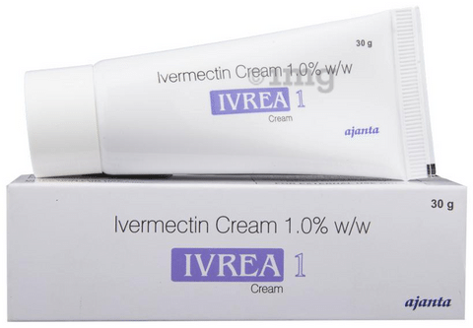

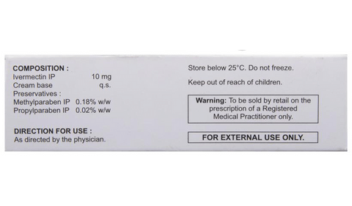

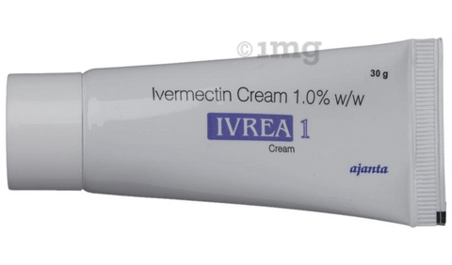

* 1
* 2
* 3
* 4

**PRODUCT INTRODUCTION**

Evasure Cream is a medicine used in the treatment of rosacea, which is an inflammatory condition that affects face. It helps in reducing the redness, swelling and pimples associated with rosacea.  
  
Your doctor will explain how to use Evasure Cream and how much you need. Read the instructions that come with the medicine to make sure you use it correctly. It is applied to the affected areas of your face as directed by your doctor. Your skin should be clean, and dry before using it. Avoid getting it into your mouth, eyes, or inside the nose. Use it regularly and at the same time of each day to get the most benefit of the medicine.  
  
Evasure Cream may cause burning, irritation, itching, and redness at the site of application. These are usually temporary and go away with time. However, if these effects persist or worsen, inform your doctor. Before using it, you should ask your doctor’s advice if you are pregnant or breastfeeding.

**USES OF IVREA CREAM**

* Rosacea
* Treatment of Parasitic infections

**BENEFITS OF IVREA CREAM**

In Rosacea

Rosacea is a reddening of the skin that mainly affects the face. Evasure Cream helps to relieve the symptoms caused by rosacea, such as redness, swelling, and pimples. This medicine usually makes you feel better quite quickly. However, you should continue taking it as long as it is prescribed even when you feel better, to get maximum benefit. If you do not see significant improvement within a few days, talk to your doctor.

**Show More**

**SIDE EFFECTS OF IVREA CREAM**

Most side effects do not require any medical attention and disappear as your body adjusts to the medicine. Consult your doctor if they persist or if you’re worried about them

Common side effects of Ivrea

* Application site reactions (burning, irritation, itching and redness)
* Dizziness
* Itching
* Peripheral edema
* Fever
* Joint pain
* Swelling of lymph nodes
* Synovitis
* Nausea
* Diarrhea
* Orthostatic hypotension (sudden lowering of blood pressure on standing)
* Facial swelling
* Fast heart rate
* Increased white blood cell count (eosinophils)
* Increased hemoglobin
* Increased alanine aminotransferase
* Increased aspartate aminotransferase
* Decreased white blood cell count

**HOW TO USE IVREA CREAM**

This medicine is for external use only. Use it in the dose and duration as advised by your doctor. Check the label for directions before use. Clean and dry the affected area and apply the cream. Wash your hands after applying, unless hands are the affected area.

**HOW IVREA CREAM WORKS**

Evasure Cream is an antiparasitic medication to be applied on skin. It works by binding to the muscle and nerve cells of worms, causing their paralysis and death. This treats your infection.

**SAFETY ADVICE**

warnings

**Alcohol**

No interaction found/established

warnings

**Pregnancy**

CONSULT YOUR DOCTOR

EvasureCream may be unsafe to use during pregnancy. Although there are limited studies in humans, animal studies have shown harmful effects on the developing baby. Your doctor will weigh the benefits and any potential risks before prescribing it to you. Please consult your doctor.

warnings

**Breast feeding**

SAFE IF PRESCRIBED

EvasureCream is probably safe to use during breastfeeding. Limited human data suggests that the drug does not represent any significant risk to the baby.

warnings

**Driving**

No interaction found/established

warnings

**Kidney**

No interaction found/established

warnings

**Liver**

No interaction found/established

**WHAT IF YOU FORGET TO TAKE IVREA CREAM?**

If you miss a dose of EvasureCream, take it as soon as possible. However, if it is almost time for your next dose, skip the missed dose and go back to your regular dosing schedule.

**All substitutes**

For informational purposes only. Consult a doctor before taking any medicines.

EvasureCream

₹5.47/gm of Cream

[Iversafe Cream](https://www.1mg.com/drugs/iversafe-cream-432237" \t "_blank)

Rockmed Pharma Pvt. Ltd.

₹4.97/cream