**EzeSkin Cream**

Prescription Required

**MANUFACTURER**

[PSP](https://www.1mg.com/manufacturer/jenburkt-pharmaceuticals-ltd-55644) Research Pvt I ltd

**SALT COMPOSITION**

[Terbinafine (1% w/w) + Ofloxacin (0.75% w/w) + Clobetasol (0.05% w/w)](https://www.1mg.com/generics/terbinafine-ofloxacin-clobetasol-508499)

**STORAGE**

Store below 30°C



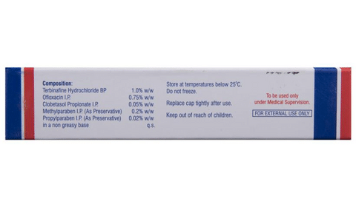

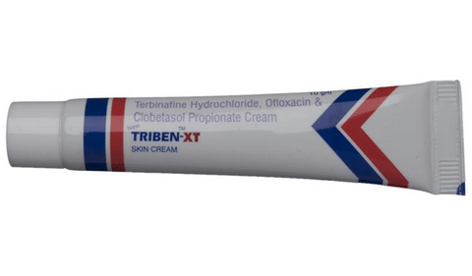

* 1
* 2
* 3
* 4

**PRODUCT INTRODUCTION**

Skin-Eze Skin Cream is a combination medicine used in the treatment of skin infections. It works by killing microorganisms that cause infection. It also blocks the release of certain chemical messengers that cause redness, swelling, and itching.  
  
Skin-Eze Skin Cream is for external use only. You should use it in the dose and duration as advised by your doctor. This medicine should be used regularly to get the most benefit from it. Do not use more than you need as it will not clear your condition faster and some side effects may be increased. If your condition goes on for longer than four weeks or gets worse at any time, let your doctor know. The effects of medicine can be increased by keeping the affected area clean and dry, and washing hands before and after treating the infection.  
  
Some of the common side effects include skin peeling, skin irritation, redness or itching at the site of application. If the side effects bother you or do not go away, let your doctor know. Avoid direct contact with eyes, nose, or mouth. If accidental exposure occurs, rinse immediately with plenty of water.  
  
It is not likely that other medicines you take by mouth or injection will affect the way it works but talk to your doctor before using it if you have used a similar medicine before and had an allergic reaction. This medicine should only be used if it is clearly needed during pregnancy.

**USES OF TRIBEN-XT CREAM**

* [Treatment of Skin infections](https://www.1mg.com/diseases/skin-infections-257)

**BENEFITS OF TRIBEN-XT CREAM**

In Treatment of Skin infections

Skin-Eze Skin Cream helps treat and control skin infections caused by bacteria such as boils, impetigo (red sores on face), infection in the hair follicle, etc. It is also used to treat fungal infections like athlete’s foot (infection between toes), Jock itch (infection of the groin area), and ringworm. It provides relief from various symptoms, such as pain, redness, itching, burning sensation and speeds up the healing process. You might see a change in your skin appearance in a week if used as prescribed by your doctor.

**SIDE EFFECTS OF TRIBEN-XT CREAM**

Most side effects do not require any medical attention and disappear as your body adjusts to the medicine. Consult your doctor if they persist or if you’re worried about them

Common side effects of Triben-XT

* Skin peeling
* Thinning of skin
* Application site reactions (burning, irritation, itching and redness)

**HOW TO USE TRIBEN-XT CREAM**

This medicine is for external use only. Use it in the dose and duration as advised by your doctor. Check the label for directions before use. Clean and dry the affected area and apply the cream. Wash your hands after applying, unless hands are the affected area.

**HOW TRIBEN-XT CREAM WORKS**

Skin-Eze Skin Cream is a combination of three medicines: Terbinafine, Ofloxacin and Clobetasol. Terbinafine is an antifungal which stops the growth of fungi on skin by preventing them from forming their own protective covering. Ofloxacin is an antibiotic. It works by preventing the bacterial cells from diving and repairing, thereby killing the bacteria. Clobetasol is a steroid which blocks the production of certain chemical messengers (prostaglandins) that make the skin red, swollen and itchy. Together, they treat your skin infection effectively.

**SAFETY ADVICE**

warnings

**Alcohol**

No interaction found/established

warnings

**Pregnancy**

CONSULT YOUR DOCTOR

Skin-Eze Skin Cream may be unsafe to use during pregnancy. Although there are limited studies in humans, animal studies have shown harmful effects on the developing baby. Your doctor will weigh the benefits and any potential risks before prescribing it to you. Please consult your doctor.

warnings

**Breast feeding**

SAFE IF PRESCRIBED

Skin-EzeSkin Cream is probably safe to use during breastfeeding. Limited human data suggests that the drug does not represent any significant risk to the baby.

warnings

**Driving**

No interaction found/established

warnings

**Kidney**

No interaction found/established

warnings

**Liver**

No interaction found/established

**WHAT IF YOU FORGET TO TAKE TRIBEN-XT CREAM?**

If you miss a dose of Skin EzeSkin Cream, apply it as soon as possible. However, if it is almost time for your next dose, skip the missed dose and go back to your regular schedule. Do not double the dose.