**Funcept Cream**

**MANUFACTURER**

[PSP](https://www.1mg.com/manufacturer/cipla-ltd-72060) Research Pvt I ltd

**SALT COMPOSITION**

[Terbinafine (1% w/w)](https://www.1mg.com/generics/terbinafine-210787)

**STORAGE**

Store below 30°C

Click here to view all substitutes

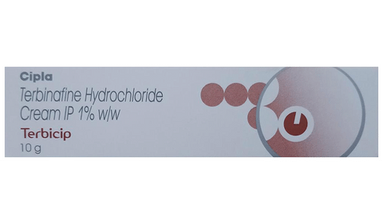

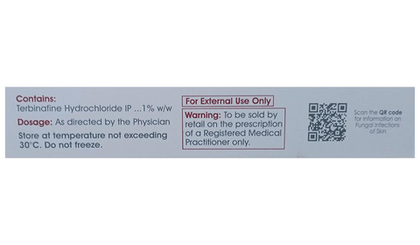

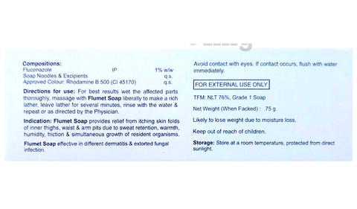

* 1
* 2
* 3

**PRODUCT INTRODUCTION**

Funcept Cream is used to treat a wide range of fungal infections of the skin and nails, including ringworm. It works by killing the fungi that cause the infection.  
  
Funcept Cream is for external use only. It should be used in the dose and duration suggested by the doctor. The affected area should be clean and dry before the application of this medicine. You must wash your hands thoroughly before and after application. Do not stop using it until you have finished the complete course, even when you feel better. If you stop using this medicine too early, the fungi may continue to grow and the infection may return or worsen.  
  
The most common side effects of this medicine include application site reactions like burning, irritation, itching, and redness, and skin peeling. These are usually mild but let your doctor know if they bother you or last more than a few days. Avoid direct contact with the eyes, nose, or mouth. If accidental exposure occurs, rinse immediately with plenty of water. You must inform your doctor if there’s no improvement even after four weeks of treatment.  
  
It is not likely that other medicines you take by mouth or injection will affect the way this medicine works but inform your doctor about all other medicines you are taking. Also, let your doctor know if you have used a similar medicine before and had an allergic reaction. Pregnant and breastfeeding mothers should consult their doctor before using it.

**USES OF FUNCEPT CREAM**

* [Fungal skin infections](https://www.1mg.com/diseases/fungal-skin-infections-638)

**BENEFITS OF FUNCEPT CREAM**

In Fungal skin infections

Funcept Cream is an antifungal medicine. It works by stopping the growth of the fungus causing the infection. This will relieve symptoms of itching, soreness, and irritation and clear up the rash on your skin. This medicine is effective in treating a wide range of fungal infections all over the body including the athlete’s foot. You should keep using it for as long as it is prescribed even if your symptoms have gone. This will ensure that the infection is completely cured and prevent it from coming back.

**SIDE EFFECTS OF FUNCEPT CREAM**

Most side effects do not require any medical attention and disappear as your body adjusts to the medicine. Consult your doctor if they persist or if you’re worried about them

Common side effects of Funcept

* Application site reactions (burning, irritation, itching and redness)
* Skin peeling
* Headache
* Diarrhea
* Rash
* Indigestion
* Abnormal liver enzyme
* Itching
* Taste change
* Nausea
* Abdominal pain
* Flatulence

**HOW TO USE FUNCEPT CREAM**

This medicine is for external use only. Use it in the dose and duration as advised by your doctor. Check the label for directions before use. Clean and dry the affected area and apply the cream. Wash your hands after applying, unless hands are the affected area.

**HOW FUNCEPT CREAM WORKS**

Funcept Cream is an antifungal medication that treats skin infections. It works by killing the fungi on the skin by destroying their cell membrane.

**SAFETY ADVICE**

warnings

**Alcohol**

No interaction found/established

warnings

**Pregnancy**

SAFE IF PRESCRIBED

Funcept Cream is generally considered safe to use during pregnancy. Animal studies have shown low or no adverse effects to the developing baby; however, there are limited human studies.

warnings

**Breast feeding**

CONSULT YOUR DOCTOR

Funcept Cream is probably unsafe to use during breastfeeding. Limited human data suggests that the drug may pass into the breastmilk and harm the baby.

warnings

**Driving**

No interaction found/established

warnings

**Kidney**

No interaction found/established

warnings

**Liver**

No interaction found/established

**WHAT IF YOU FORGET TO TAKE FUNCEPT CREAM?**

If you miss a dose of Funcept Cream, apply it as soon as possible. However, if it is almost time for your next dose, skip the missed dose and go back to your regular schedule. Do not double the dose.

**All substitutes**

For informational purposes only. Consu