**Fuzole I Lotion**

Prescription Required

**MANUFACTURER**

[PSP Research Pvt Ltd](https://www.1mg.com/manufacturer/intas-pharmaceuticals-ltd-55048)

**SALT COMPOSITION**

[Luliconazole (1% w/v)](https://www.1mg.com/generics/luliconazole-211411)

**STORAGE**

Store below 30°C

Click here to view all substitutes

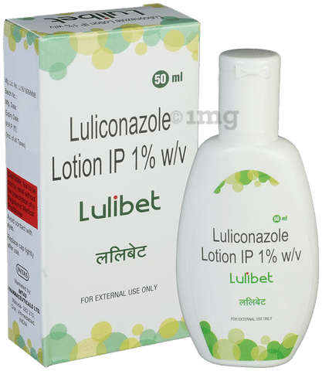

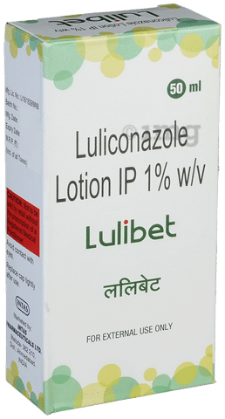

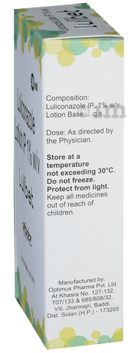

* 1
* 2
* 3
* 4
* 5
* 6

**PRODUCT INTRODUCTION**

Fuzole I Lotion is an antifungal medicine used to treat fungal infections of the skin such as athlete’s foot, Dhobie Itch, thrush, ringworm, and dry, flaky skin. It works by killing the fungi that cause these infections.  
  
Fuzole I Lotion should be used in the dose and duration as prescribed by your doctor. Do not use it more often or in higher quantity than prescribed as this will not clear your condition faster and may only increase the side effects. Skin infections will usually get better after 2 to 4 weeks of use. Let your doctor know if your condition does not improve. The effect of the medicine can be increased by keeping the affected area clean and dry, and washing hands before and after use. If you have athlete’s foot, wash your socks or tights thoroughly and change your shoes daily if possible.  
  
The most common side effects of this medicine include burning sensation, irritation, itching, and redness at the site of application. It may also cause dryness, peeling, or blistering of the skin. These are not usually serious and resolve with time. Call your doctor if these persist or bother you. Seek emergency help if you notice signs of an allergic reaction such as a rash, swelling of the lips, throat, or face, swallowing or breathing problems, and nausea. Avoid direct contact with your eyes. In case of accidental contact, wash your eyes with water and seek immediate medical attention.  
  
It is not likely that other medicines you take by mouth or injection will affect the way this medicine works, but talk to your doctor before using it if you have recently used another medicine that contains a steroid or had an allergic reaction to another antifungal medicine. Ask your doctor before using this medicine if you are pregnant or breastfeeding.

**USES OF FUZOLE I LOTION**

* [Treatment of Fungal skin infections](https://www.1mg.com/diseases/fungal-skin-infections-638)

**BENEFITS OF FUZOLE I LOTION**

In Treatment of Fungal skin infections

Fuzole I Lotion is an antifungal medicine. It kills and prevents the growth of fungus. This relieves the symptoms caused by the infection. It may be used to treat infections such as athlete’s foot, Dhobie Itch, thrush, ringworm, and dry, flaky skin. You should keep using it for as long as it is prescribed even if your symptoms have gone. This will prevent the infection from coming back. Using this medicine as prescribed will relieve pain and itching and may help you feel more comfortable with your skin.

**SIDE EFFECTS OF FUZOLE I LOTION**

Most side effects do not require any medical attention and disappear as your body adjusts to the medicine. Consult your doctor if they persist or if you’re worried about them

Common side effects of Fuzole I

* Application site reactions (burning, irritation, itching and redness)
* Dry skin
* Skin peeling
* Blisters on skin

**HOW TO USE FUZOLE I LOTION**

This medicine is for external use only. Use this medicine in the dose and duration as advised by your doctor. Shake it well and apply to the area evenly.

**HOW FUZOLE I LOTION WORKS**

Fuzole I Lotion is an antifungal medication that treats skin infections. It kills the infection-causing fungi by destroying their cell membrane. This relieves discomfort, itching, and irritation on the skin.

**SAFETY ADVICE**

warnings

**Alcohol**

No interaction found/established

warnings

**Pregnancy**

CONSULT YOUR DOCTOR

Fuzole I Lotion may be unsafe to use during pregnancy. Although there are limited studies in humans, animal studies have shown harmful effects on the developing baby. Your doctor will weigh the benefits and any potential risks before prescribing it to you. Please consult your doctor.

warnings

**Breast feeding**

CAUTION

Fuzole I Lotion should be used with caution during breastfeeding. Breastfeeding should be held until the treatment of the mother is completed and the drug is eliminated from her body.

warnings

**Driving**

No interaction found/established

warnings

**Kidney**

No interaction found/established

warnings

**Liver**

No interaction found/established