**Hydrsol Soft Cream**

Prescription Required

**MANUFACTURER**

[Intas Pharmaceuticals Ltd](https://www.1mg.com/manufacturer/intas-pharmaceuticals-ltd-55048)

**SALT COMPOSITION**

[Hydroquinone (2% w/w) + Tretinoin (0.025% w/w) + Hydrocortisone (0.5% w/w)](https://www.1mg.com/generics/hydroquinone-tretinoin-hydrocortisone-401923)

**STORAGE**

Store below 30°C

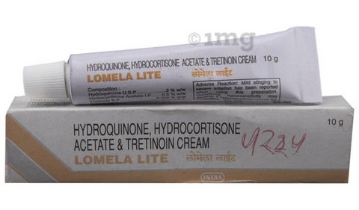

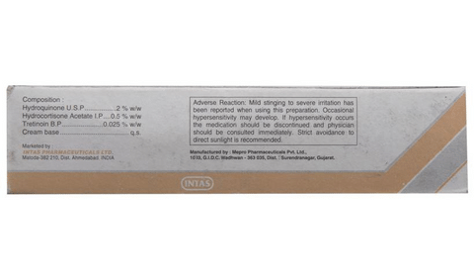

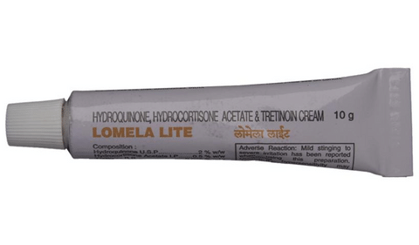

* 1
* 2
* 3
* 4

**PRODUCT INTRODUCTION**

Hydrsol Soft Cream is a prescription medicine having a combination of medicines that is used to treat melasma. It helps in quick skin renewal. It provides relief from redness, swelling and itching.  
  
Hydrsol Soft Cream should be used in the dose and duration as advised by your doctor. Wash your hands before using this medicine. It is advised to check the label for directions before use. It is for external use only.  
  
Do not use this medicine more than the recommended dose. Inform your doctor if you have known allergies from this medicine. The common side effects of this medicine include thinning of the skin, dry skin, burning, irritation, itching and redness at the application site.  
  
If these side effects or any other symptoms which you think are because of this medicine persist for a longer duration, please consult your doctor. Inform your doctor if you are pregnant or are suffering from any other disease. This medicine is not safe to use in breastfeeding mothers.

**USES OF HYDRSOL SOFT CREAM**

* Melasma

**BENEFITS OF HYDRSOL SOFT CREAM**

In Melasma

Melasma is a common skin problem that causes dark, discolored patches on your skin primarily on the face. It frequently occurs during pregnancy and menopause. Hydrsol Soft Cream helps to lighten these dark patches by reducing the production of melanin (natural skin pigment). It lightens skin color and gives a smoother-looking skin. Hydrsol Soft Cream also reduces any swelling, redness and itchiness especially if you have a sensitive skin. This helps boost your self-esteem and confidence as your appearance changes. Keep using it for as long as it is prescribed to get the full benefits.

**SIDE EFFECTS OF HYDRSOL SOFT CREAM**

Most side effects do not require any medical attention and disappear as your body adjusts to the medicine. Consult your doctor if they persist or if you’re worried about them

Common side effects of Lomela Lite

* Thinning of skin
* Dry skin
* Application site reactions (burning, irritation, itching and redness)

**HOW TO USE HYDRSOL SOFT CREAM**

This medicine is for external use only. Use it in the dose and duration as advised by your doctor. Check the label for directions before use. Clean and dry the affected area and apply the cream. Wash your hands after applying, unless hands are the affected area.

**HOW HYDRSOL SOFT CREAM WORKS**

Hydrsol Soft Cream is a combination of three medicines: Hydroquinone, Tretinoin and Hydrocortisone which treat melasma (dark spots on skin). Hydroquinone is a skin lightening medicine. It reduces the amount of a skin pigment (melanin) that causes darkening of skin. Tretinoin is a form of vitamin A that helps the skin to renew itself more quickly. Hydrocortisone is a steroid which blocks the production of certain chemical messengers (prostaglandins) that make the skin red, swollen and itchy.

**SAFETY ADVICE**

warnings

**Alcohol**

No interaction found/established

warnings

**Pregnancy**

CONSULT YOUR DOCTOR

Hydrsol Soft Cream may be unsafe to use during pregnancy. Although there are limited studies in humans, animal studies have shown harmful effects on the developing baby. Your doctor will weigh the benefits and any potential risks before prescribing it to you. Please consult your doctor.

warnings

**Breast feeding**

UNSAFE

Hydrsol Soft Cream is unsafe to use during breastfeeding. Data suggests that the drug may cause toxicity to the baby.

warnings

**Driving**

No interaction found/established

warnings

**Kidney**

No interaction found/established

warnings

**Liver**

No interaction found/established

**WHAT IF YOU FORGET TO TAKE HYDRSOL SOFT CREAM?**

If you miss a dose of Hydrsol Soft Cream, apply it as soon as possible. However, if it is almost time for your next dose, skip the missed dose and go back to your regular schedule. Do not double the dose.

**All substitutes**

For informational purposes only. Consult a doctor before taking any medicines.

No substitutes found for this medicine

**Quick tips**



* You have been prescribed Hydrsol Soft Cream to reduce skin pigmentation.
* Along with applying Hydrsol Soft Cream, wear long-sleeved clothing, sunglasses, hat whenever you step outside in the hot sun for better protection.
* Don't cover the area being treated with airtight dressings such as bandages unless directed by a doctor.
* Use moisturizer regularly to overcome skin dryness during the course of treatment.
* You may also use certain safe cosmetics (after consulting with your doctor) in order to lighten pigmentation.
* Before using Hydrsol Soft Cream, inform your doctor if you have any skin problems or are applying any other medicines to your skin.