**Neosure Cream**

Prescription Required

**MANUFACTURER**

[PSP](https://www.1mg.com/manufacturer/zenlabs-ethica-ltd-77189) Rsearch Pvt I ltd

**SALT COMPOSITION**

[Clobetasol (0.05% w/w) + Miconazole (2% w/w) + Neomycin (0.5% w/w)](https://www.1mg.com/generics/clobetasol-miconazole-neomycin-401118)

**STORAGE**

Store below 30°C

Click here to view all substitutes

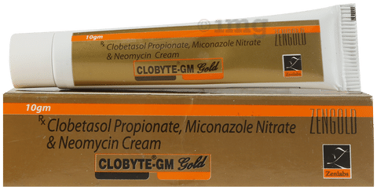



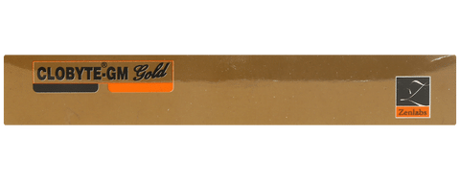

* 1
* 2
* 3
* 4
* 5
* 6

**PRODUCT INTRODUCTION**

Neosure Cream is a combination medicine used in the treatment of various types of skin infections. It minimizes symptoms of inflammation such as redness, swelling, and itching by acting against the infection-causing microorganisms.  
  
Neosure Cream is only meant for external use and should be used as advised by your doctor. A thin layer of the medicine should be applied only to the affected areas of the skin with clean and dry hands. If it gets into your eyes, nose, mouth, or vagina rinse with water. It may take several days to weeks for your symptoms to improve, but you should keep using this medicine regularly. The course of the treatment should be completed to ensure better efficacy of the medicine. If your condition does not improve or gets worse, you should talk to your doctor.  
  
The most common side effect of this medicine includes itching, dryness, redness, and burning sensation at the application site. These are usually self-limiting. Serious side effects are rare. You must consult the doctor if you experience any allergic reaction (rashes, itching, swelling, shortness of breath, etc.).  
  
Before taking this medicine, it is important to tell your doctor if you are taking or have recently taken any other medicines for the same disease or other diseases. Pregnant and breastfeeding women should take this medicine with proper consultation and caution. If you are a known allergic to the medicine, you must refrain from using this medicine. You should consult the doctor about prescribing an alternative medicine for your condition.

**USES OF CLOBYTE GM CREAM**

* [Treatment of Skin infections](https://www.1mg.com/diseases/skin-infections-257)

**BENEFITS OF CLOBYTE GM CREAM**

In Treatment of Skin infections

Neosure Cream is a combination of medicines used to treat skin infections caused by microorganisms such as bacteria and fungi. It kills and stops the growth of infection-causing microorganisms, thereby clearing the infection and relieving the symptoms. It also blocks the release of chemicals that cause symptoms such as itching, redness, and swelling. Therefore this medicine relieves the inflammation due to these infections.  
  
You should use NeosureCream for as long as it is prescribed, even if your symptoms disappear, otherwise they may come back. Depending on the type of infection you are treating, this may be several weeks. Even after your infection is completely cured, you may have to apply it occasionally to prevent the symptoms from returning.

**SIDE EFFECTS OF CLOBYTE GM CREAM**

Most side effects do not require any medical attention and disappear as your body adjusts to the medicine. Consult your doctor if they persist or if you’re worried about them

Common side effects of Clobyte GM

* Application site reactions (burning, irritation, itching and redness)
* Thinning of skin

**HOW TO USE CLOBYTE GM CREAM**

This medicine is for external use only. Use it in the dose and duration as advised by your doctor. Check the label for directions before use. Clean and dry the affected area and apply the cream. Wash your hands after applying, unless hands are the affected area.

**HOW CLOBYTE GM CREAM WORKS**

NeosureCream is a combination of three medicines: Clobetasol, Miconazole and Neomycin, which treats skin infections. Clobetasol is a steroid medicine. It blocks the production of certain chemical messengers (prostaglandins) that make the skin red, swollen and itchy. Miconazole is an antifungal which stops the growth of fungi by preventing them from forming their own protective covering. Neomycin is an antibiotic. It stops bacterial growth by preventing the synthesis of essential proteins required by the bacteria to carry out vital functions.

**SAFETY ADVICE**

warnings

**Alcohol**

No interaction found/established

warnings

**Pregnancy**

CONSULT YOUR DOCTOR

NeosureCream may be unsafe to use during pregnancy. Although there are limited studies in humans, animal studies have shown harmful effects on the developing baby. Your doctor will weigh the benefits and any potential risks before prescribing it to you. Please consult your doctor.

warnings

**Breast feeding**

SAFE IF PRESCRIBED

NeosureCream is probably safe to use during breastfeeding. Limited human data suggests that the drug does not represent any significant risk to the baby.

warnings

**Driving**

No interaction found/established

warnings

**Kidney**

No interaction found/established

warnings

**Liver**

No interaction found/established

**WHAT IF YOU FORGET TO TAKE CLOBYTE GM CREAM?**

If you miss a dose of Neosure Cream, apply it as soon as possible. However, if it is almost time for your next dose, skip the missed dose and go back to your regular schedule. Do not double the dose.