**Scabis PlusCream**

**MANUFACTURER**

[PSP](https://www.1mg.com/manufacturer/abbott-1) Research Pvt I ltd

**SALT COMPOSITION**

[Hydrocortisone (0.25% w/w) + Crotamiton (10% w/w)](https://www.1mg.com/generics/hydrocortisone-crotamiton-401901)

**STORAGE**

Store below 30°C

Click here to view all substitutes

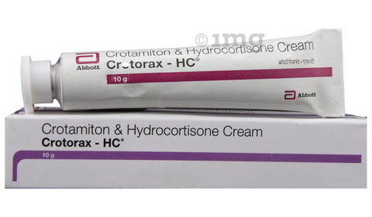

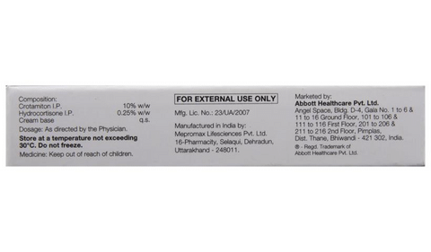

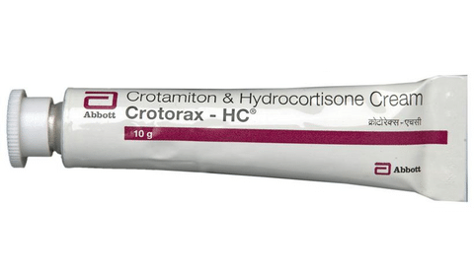

* 1
* 2
* 3
* 4

**PRODUCT INTRODUCTION**

Scabis Plus Cream is a combination medicine which is used in the treatment of scabies. It works by blocking the production of certain chemical messengers that makes the skin red, swollen and itchy. It also kills the tiny insects and their eggs.  
  
Scabis Plus Cream is for external use only. You should always use it exactly as your doctor has told you. The affected area should be clean and dry before application. You must wash your hands thoroughly before and after applying this medicine. This medicine should be used regularly to get the most benefit from it. Do not use more than you need as it will not clear your condition faster and some side effects may be increased. If your condition goes on for longer than four weeks or gets worse at any time, let your doctor know. You can help this medicine work better by keeping the affected areas clean.  
  
Common side effects include rash, redness or itching at the site of application. Most of these are temporary and usually resolve with time. Please consult your doctor if these side effects persist for a longer duration. Avoid direct contact with the cream or ointment with your eyes. In case of direct contact, wash your eyes with water and seek immediate medical attention.  
  
Before taking this medicine, you should tell your doctor if you have any kidney or liver diseases so that your doctor can prescribe a suitable dose for you. You should also tell your doctor if you are pregnant, planning pregnancy or breastfeeding.

**USES OF SCABIS PLUSCREAM**

* [Scabies](https://www.1mg.com/diseases/scabies-376)

**BENEFITS OF SCABIS PLUSCREAM**

In Scabies

Scabies is a condition caused by tiny insects called mites that infest and irritate your skin. Scabis Plus Cream kills the mites and their eggs present on the skin. This gives relief from itching, swelling and redness. Generally, the cream should be applied to the whole body except the face but follow your doctor’s advice. It should be thoroughly washed off after 8-12 hours. Often one application is enough to treat the condition completely but sometimes a second one may be required a week later. This is because the treatment might kill the mites quickly, but the itching can carry on for a few weeks. Avoid close contact with people to prevent the spread of scabies.

**HOW TO USE SCABIS PLUSCREAM**

This medicine is for external use only. Use it in the dose and duration as advised by your doctor. Check the label for directions before use. Clean and dry the affected area and apply the cream. Wash your hands after applying, unless hands are the affected area.

**HOW SCABIS PLUSCREAM WORKS**

Scabis PlusCream is a combination of two medicines: Hydrocortisone and Crotamiton. Hydrocortisone is a steroid which blocks the production of certain chemical messengers (prostaglandins) that make the skin red, swollen and itchy. Crotamiton is an antiparasitic which works by killing the tiny insects (mites) and their eggs, which cause scabies.

**SAFETY ADVICE**

warnings

**Alcohol**

No interaction found/established

warnings

**Pregnancy**

CONSULT YOUR DOCTOR

Scabis PlusCream may be unsafe to use during pregnancy. Although there are limited studies in humans, animal studies have shown harmful effects on the developing baby. Your doctor will weigh the benefits and any potential risks before prescribing it to you. Please consult your doctor.

warnings

**Breast feeding**

CONSULT YOUR DOCTOR

Information regarding the use of Scabis PlusCream during breastfeeding is not available. Please consult your doctor.

warnings

**Driving**

No interaction found/established

warnings

**Kidney**

No interaction found/established

warnings

**Liver**

No interaction found/established

**WHAT IF YOU FORGET TO TAKE SCABIS PLUSCREAM?**

If you miss a dose of Scabis PlusCream, apply it as soon as possible. However, if it is almost time for your next dose, skip the missed dose and go back to your regular schedule. Do not double the dose.