**Serzole 2 Cream**

**MANUFACTURER**

[PSP](https://www.1mg.com/manufacturer/glenmark-pharmaceuticals-ltd-72198) Research Pvt I ltd

**SALT COMPOSITION**

[Sertaconazole (2% w/w)](https://www.1mg.com/generics/sertaconazole-210679)

**STORAGE**

Store below 30°C

Click here to view all substitutes



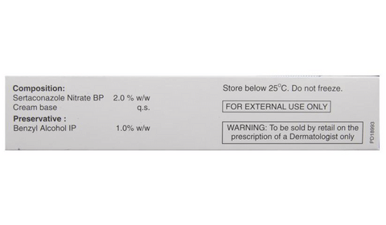

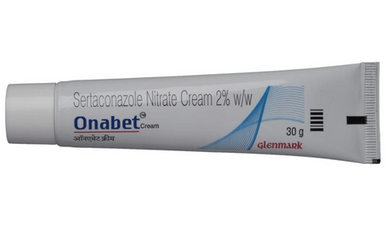

* 1
* 2
* 3
* 4

**PRODUCT INTRODUCTION**

Serzole 2 Cream is an antifungal medicine used to treat fungal infections of the skin. It works by killing the fungus that causes infections such as athlete’s foot, Dhobie Itch, thrush, ringworm, and dry, flaky skin.  
  
Serzole 2 Cream should be used in the dose and duration as prescribed by your doctor. Use it regularly to get the most benefit. Do not use more than you need, as that will not clear your condition faster and may only increase the side effects. Do not use the medicine for longer than prescribed and let the doctor know if your condition does not improve after 2 to 4 weeks of treatment. The effects of the medicine can be increased by keeping the affected area clean, dry, and washing hands before and after use.  If you have athlete’s foot, wash your socks or tights thoroughly and change your shoes daily if possible.  
  
The most common side effects of using Serzole 2 Cream include application site reactions such as burning, irritation, itching, and redness. Avoid direct contact with your eyes. In case of accidental contact, wash your eyes with water and seek immediate medical attention.  
  
It is not likely that other medicines you take by mouth or injection will affect the way this medicine works, but talk to your doctor before using it if you have recently used another medicine that contains a steroid or had an allergic reaction to another antifungal medicine. Let your doctor know if you are pregnant or breastfeeding.

**USES OF ONABET CREAM**

* [Treatment of Fungal skin infections](https://www.1mg.com/diseases/fungal-skin-infections-638)
* [Treatment of Fungal infections](https://www.1mg.com/diseases/fungal-infections-269)

**BENEFITS OF ONABET CREAM**

In Treatment of Fungal skin infections

Serzole 2 Cream is an antifungal medicine. It kills and prevents the growth of fungus. This relieves the symptoms caused by the infection. It may be used to treat infections such as athlete’s foot, Dhobie Itch, thrush, ringworm, and dry, flaky skin. You should keep using it for as long as it is prescribed even if your symptoms have gone. This will prevent the infection from coming back. Using this medicine as prescribed will relieve pain and itching and may help you feel more comfortable with your skin.

**Show More**

**SIDE EFFECTS OF ONABET CREAM**

Most side effects do not require any medical attention and disappear as your body adjusts to the medicine. Consult your doctor if they persist or if you’re worried about them

Common side effects of Onabet

* Application site reactions (burning, irritation, itching and redness)
* Skin irritation

**HOW TO USE ONABET CREAM**

This medicine is for external use only. Use it in the dose and duration as advised by your doctor. Check the label for directions before use. Clean and dry the affected area and apply the cream. Wash your hands after applying, unless hands are the affected area.

**HOW ONABET CREAM WORKS**

Serzole 2 Cream is an antifungal medication which treats skin infections. It works by killing the fungi on the skin by destroying their cell membrane.

**SAFETY ADVICE**

warnings

**Alcohol**

No interaction found/established

warnings

**Pregnancy**

CONSULT YOUR DOCTOR

Serzole 2 Cream may be unsafe to use during pregnancy. Although there are limited studies in humans, animal studies have shown harmful effects on the developing baby. Your doctor will weigh the benefits and any potential risks before prescribing it to you. Please consult your doctor.

warnings

**Breast feeding**

CONSULT YOUR DOCTOR

Information regarding the use of Serzole 2 Cream during breastfeeding is not available. Please consult your doctor.

warnings

**Driving**

No interaction found/established

warnings

**Kidney**

No interaction found/established

warnings

**Liver**

No interaction found/established

**WHAT IF YOU FORGET TO TAKE ONABET CREAM**