[Home](https://www.1mg.com/)[Personal Care](https://www.1mg.com/categories/personal-care-18)[Skin Care](https://www.1mg.com/categories/skin-care-19)[Sunscreen](https://www.1mg.com/categories/sunscreen-210)Suncros Sunscreen Lotion Spf 26

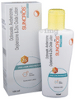

thumbnail

thumbnail

thumbnail

thumbnail

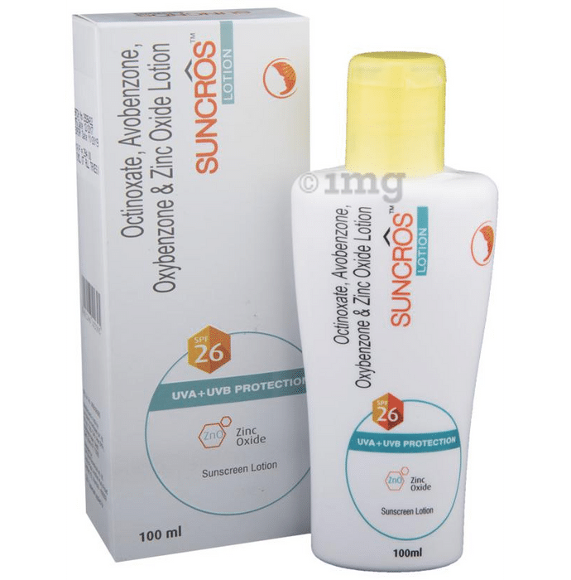

**Sunscreen Lotion SPF 26**

[Sun Pharmaceutical Industries Ltd](https://www.1mg.com/manufacturer/sun-pharmaceutical-industries-ltd-54979)

4.4

120 Ratings & 37 Reviews

215 people bought this recently

₹342~~₹389~~12% off

₹342+ free shipping and 2% Extra NeuCoins with

Inclusive of all taxes

1 Bottle

of100 ml Lotion

**ADD TO CART**

**Earliest delivery by 10pm, Tomorrow**

Delivering to:

**110020, New Delhi**

[](https://www.1mg.com/categories/featured/top-brands/power-gummies-1230)

Additional offers

**Paytm Wallet**: Pay with Paytm Wallet on Tata 1mg for ₹999 or more and get 5% cashback up to ₹75. Offer ends 5th July 2023.

**Show more**

Information aboutEvasmile Sunscreen Lotion SPF 26

Evasmile Sunscreen Lotion contains Octinoxate, Avobenzone,Oxybenzone, and zinc oxide.Evasmiles Lotion contains zinc oxide for complete UV-A & UV-B protection and it has superior UV-A protection compared to ordinary sunscreens.  
Evasmile Lotion is a non-greasy sunscreen with water resistant formula.Evasmile Lotion is gel based so it is good for oily skinned people as well. It gets absorbed very quickly and does not make the skin look shiny.  
Evasmile Lotion is specially suited for oily skin, humid conditions and excessive sweating conditions.  
  
Key Ingredients:

Octinoxate USP

Oxybenzone USP

Avobenzone USP

Zinc Oxide IP

Preservative Phenoxyethanol IP

   
Direction for Use:  
Apply evenly on face, neck and exposed areas of skin  
Use 20-30 minutes prior to sun exposure  
Re-apply as required, especially after swimming, sweating  
 